

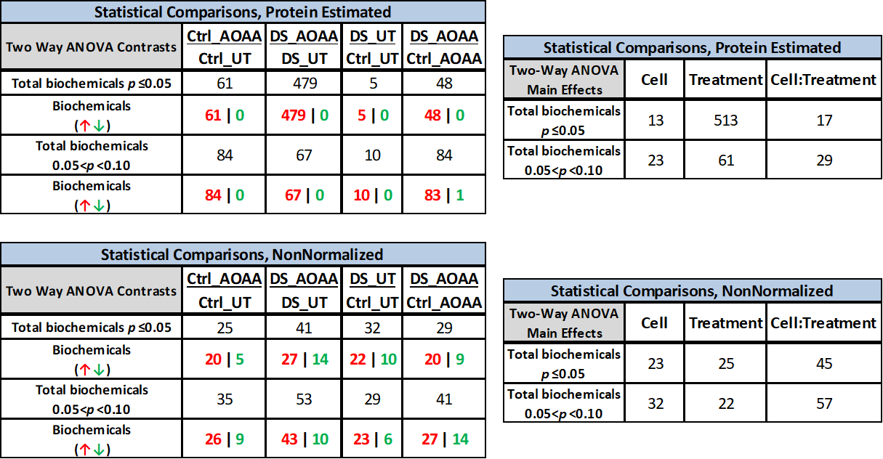
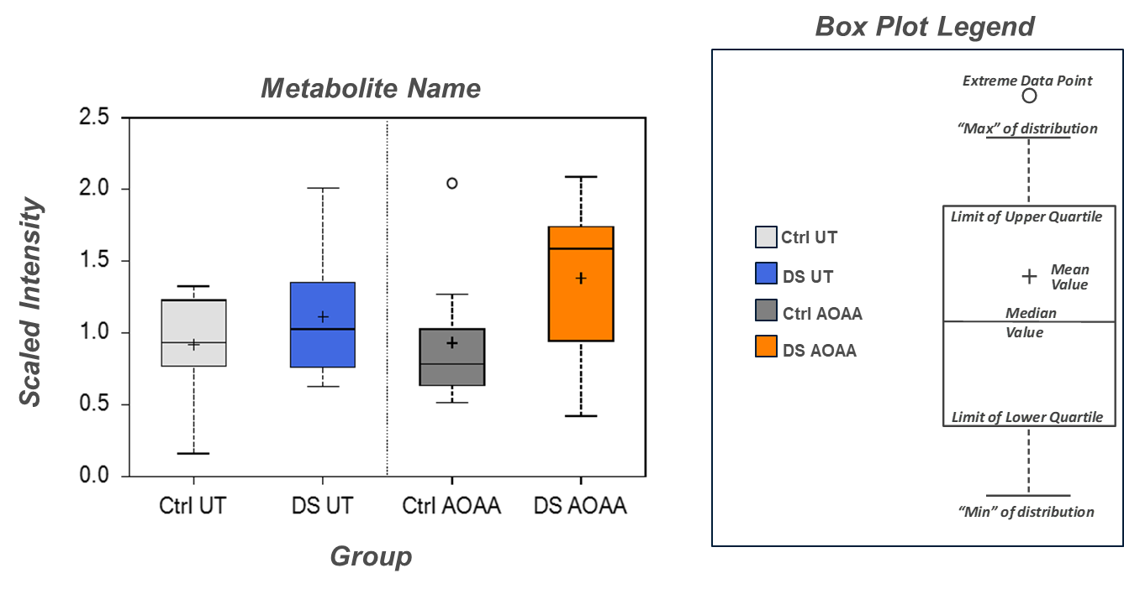
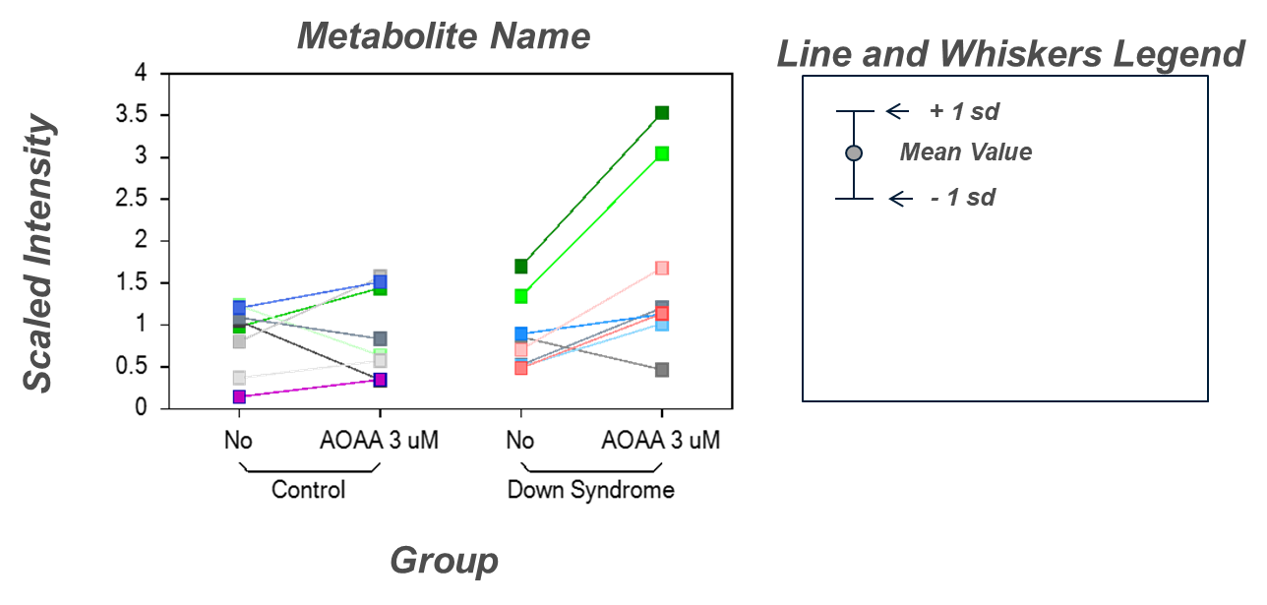

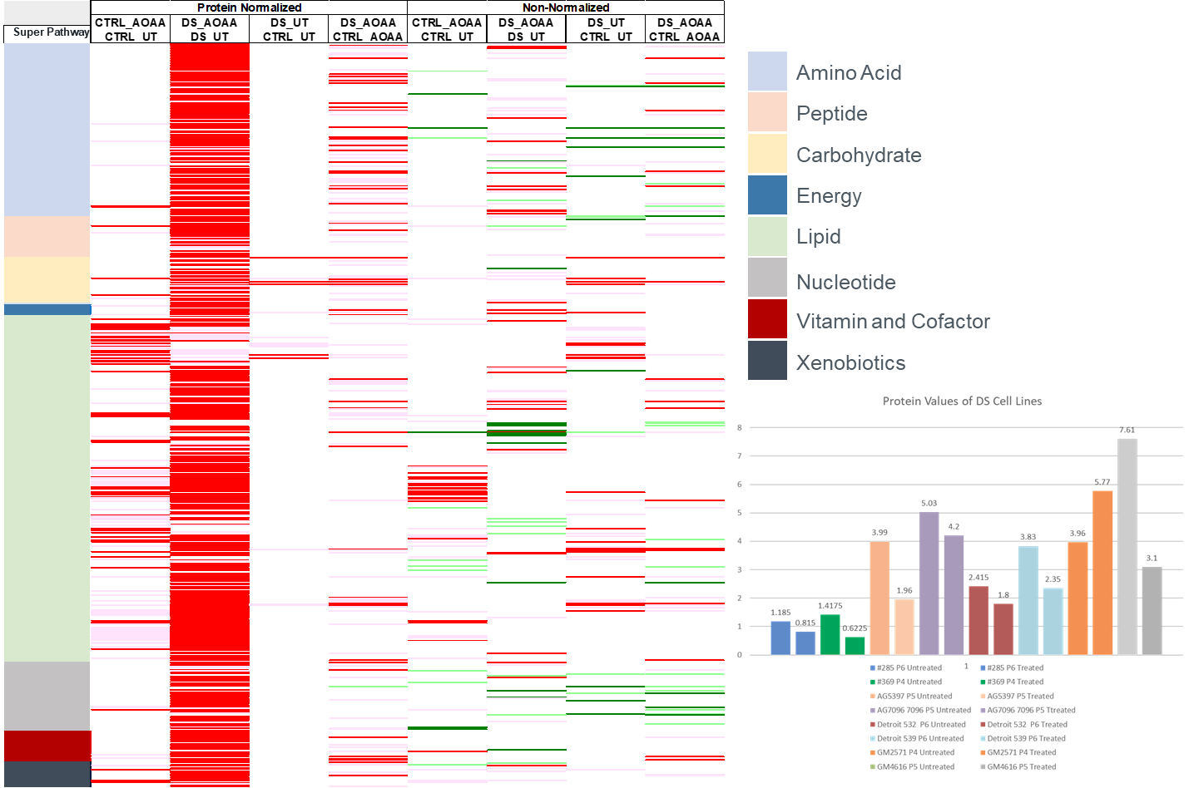
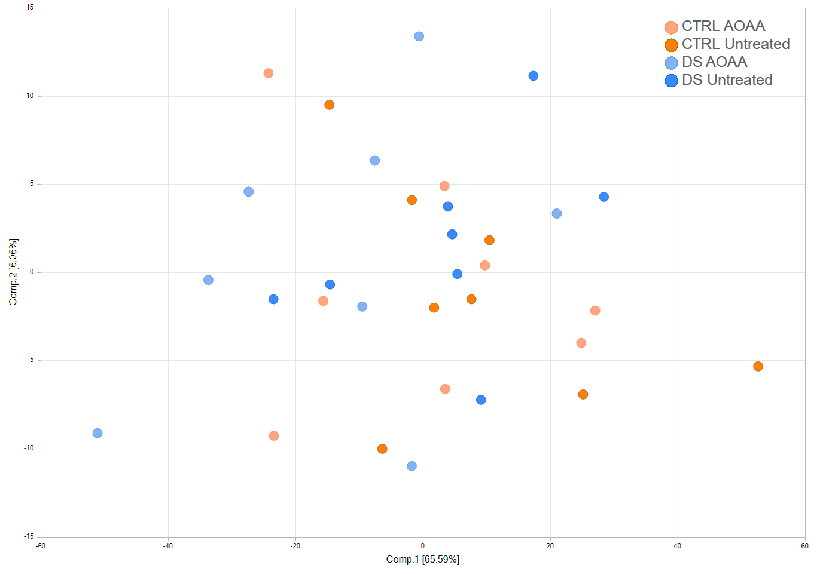
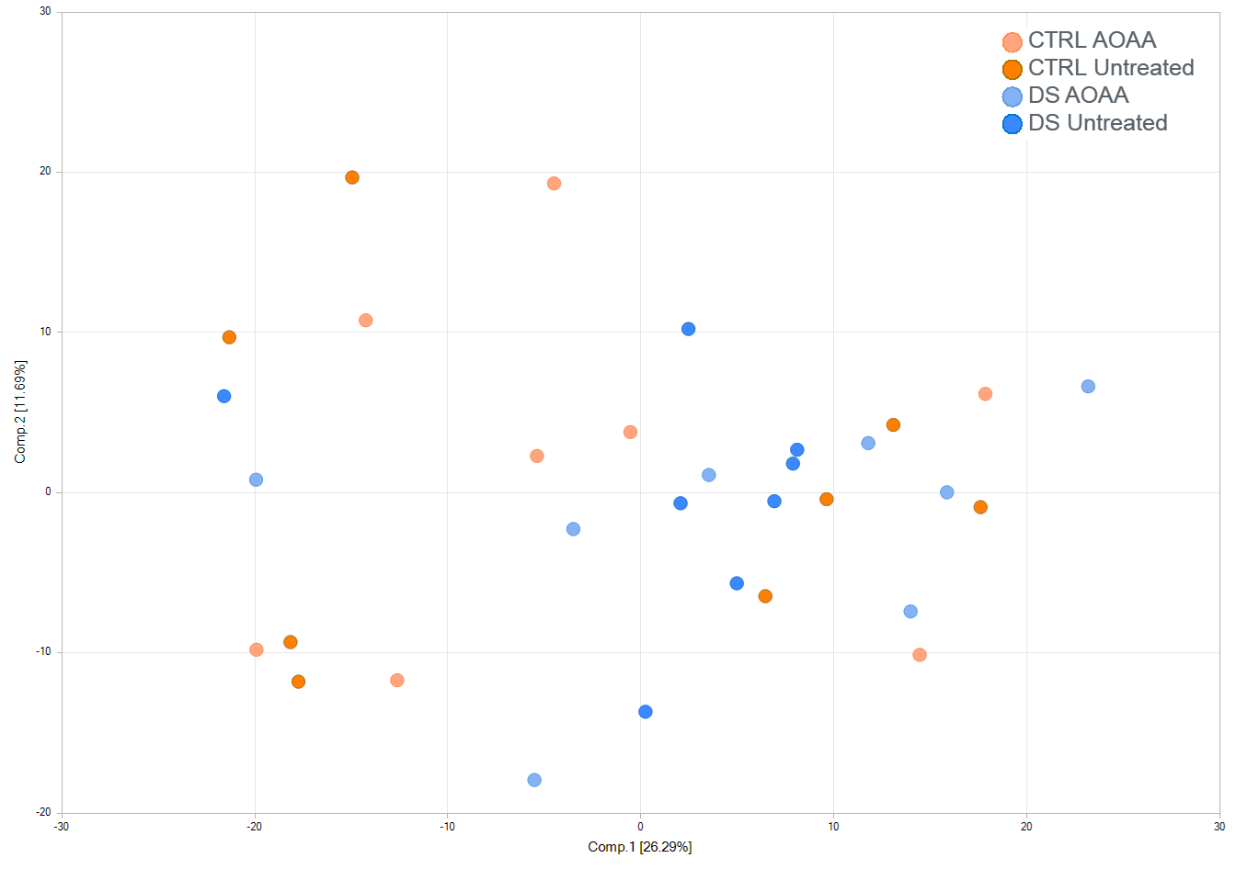
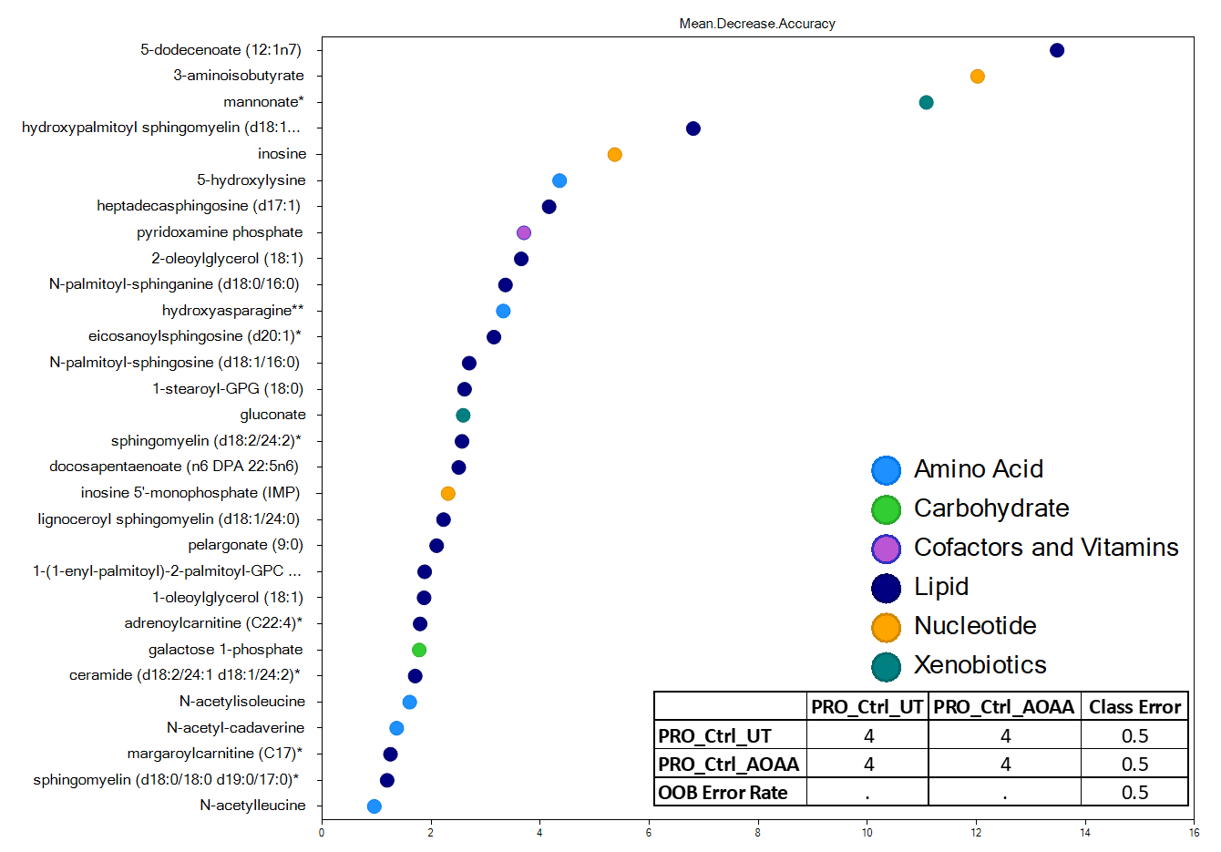
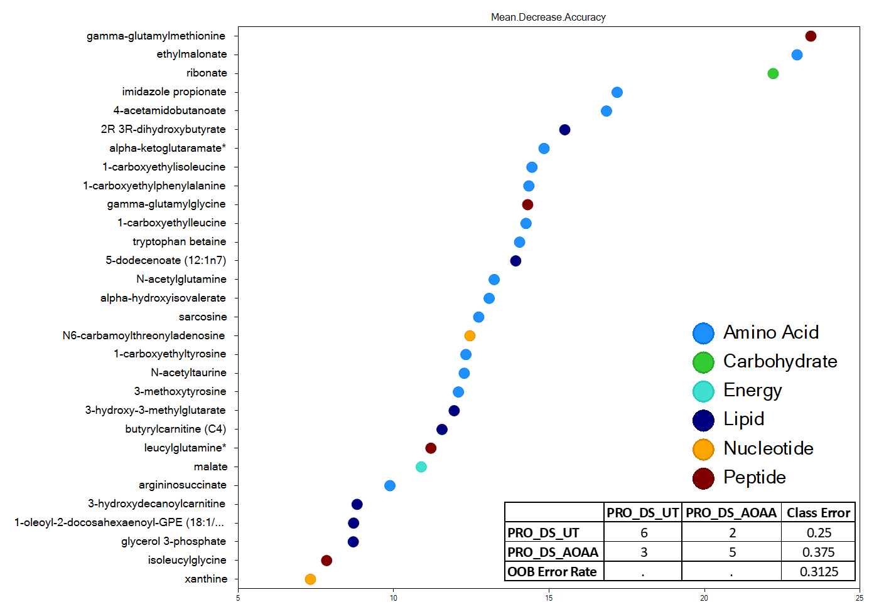
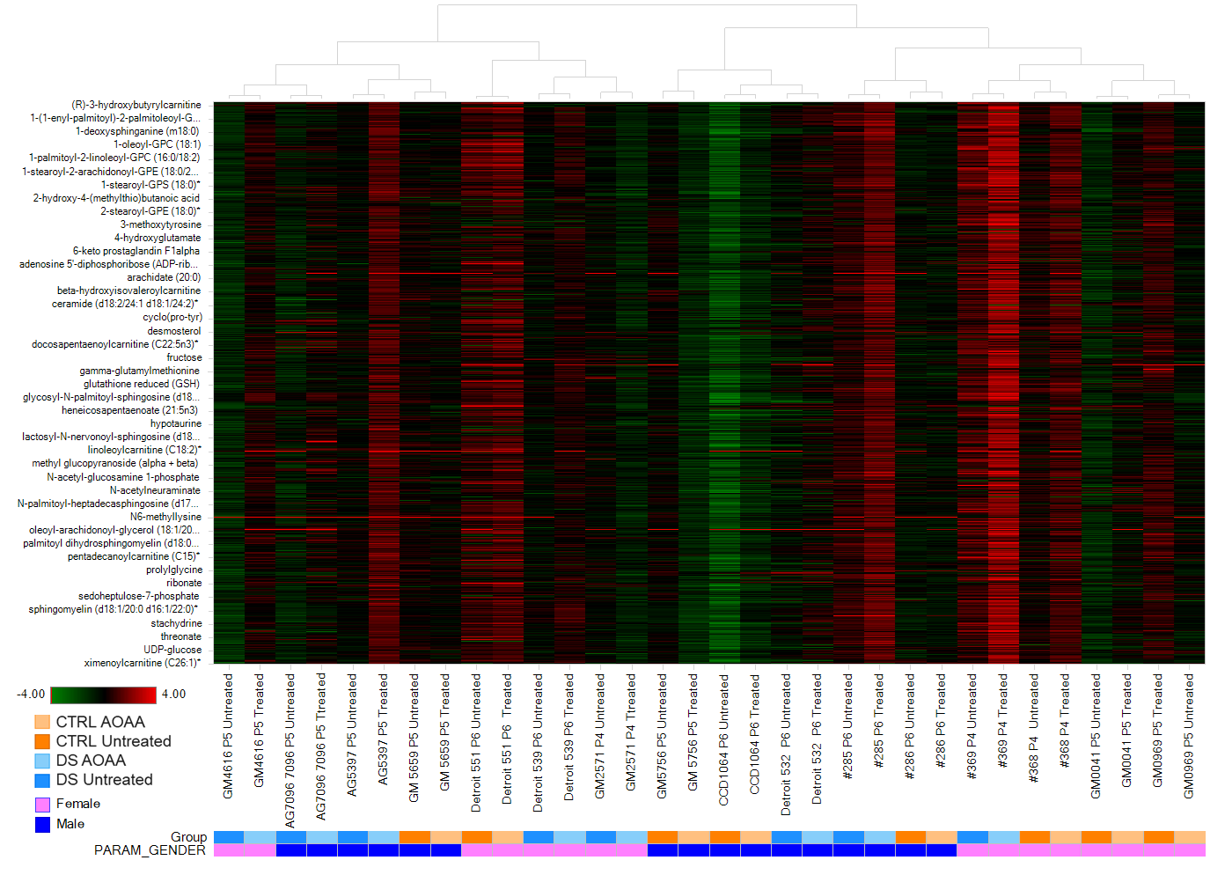
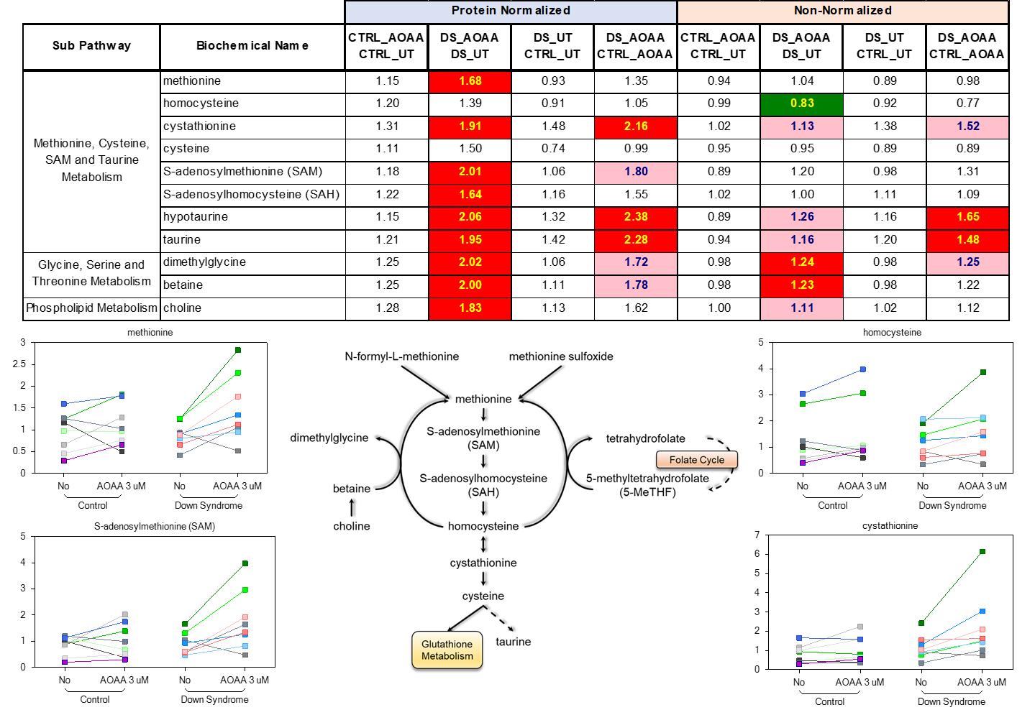
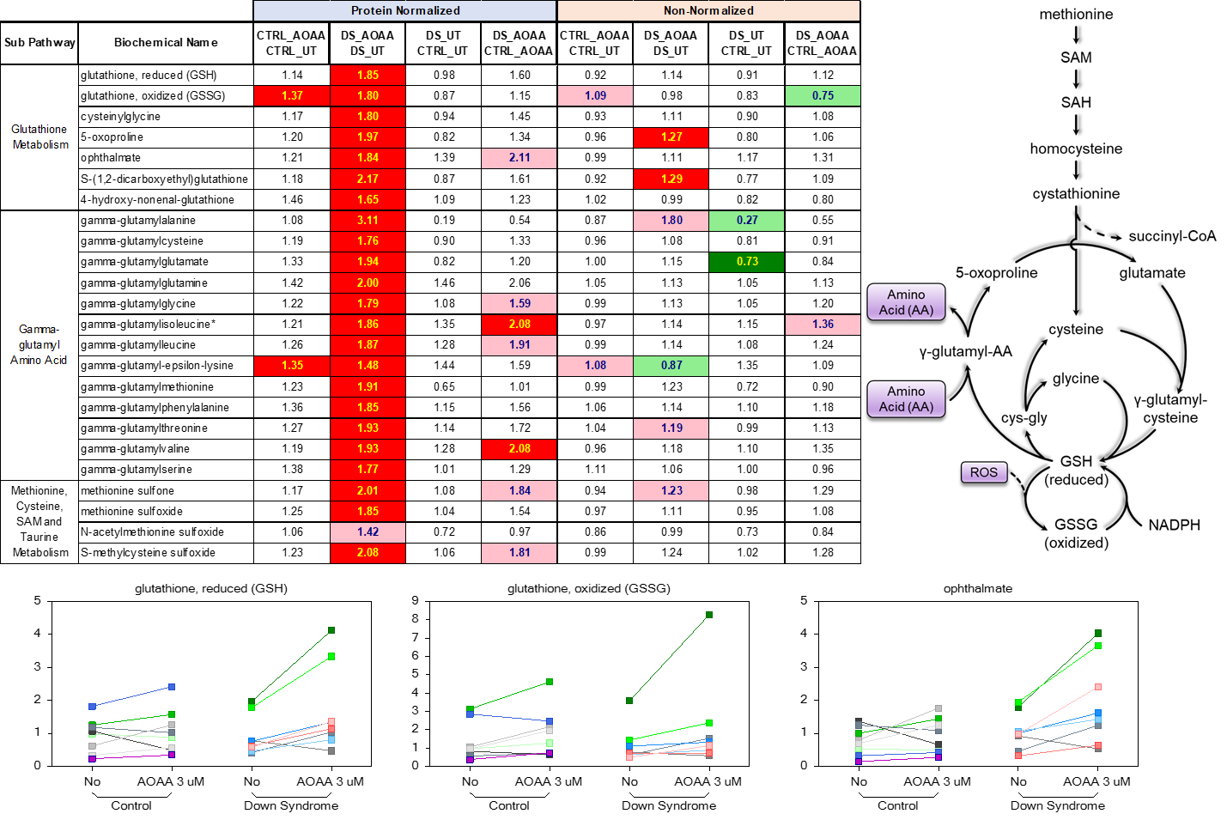
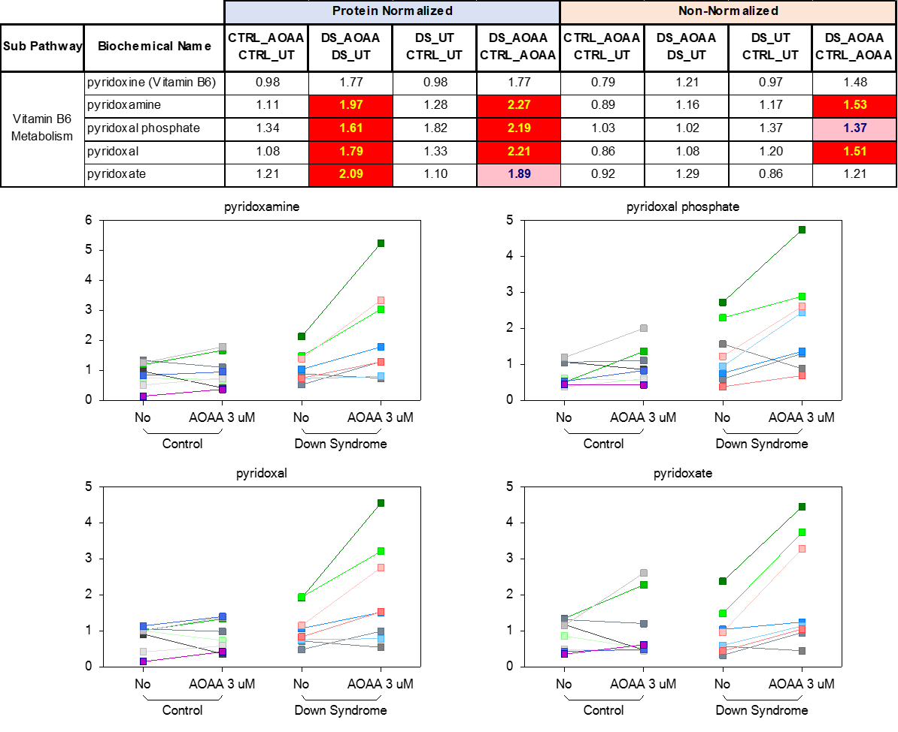
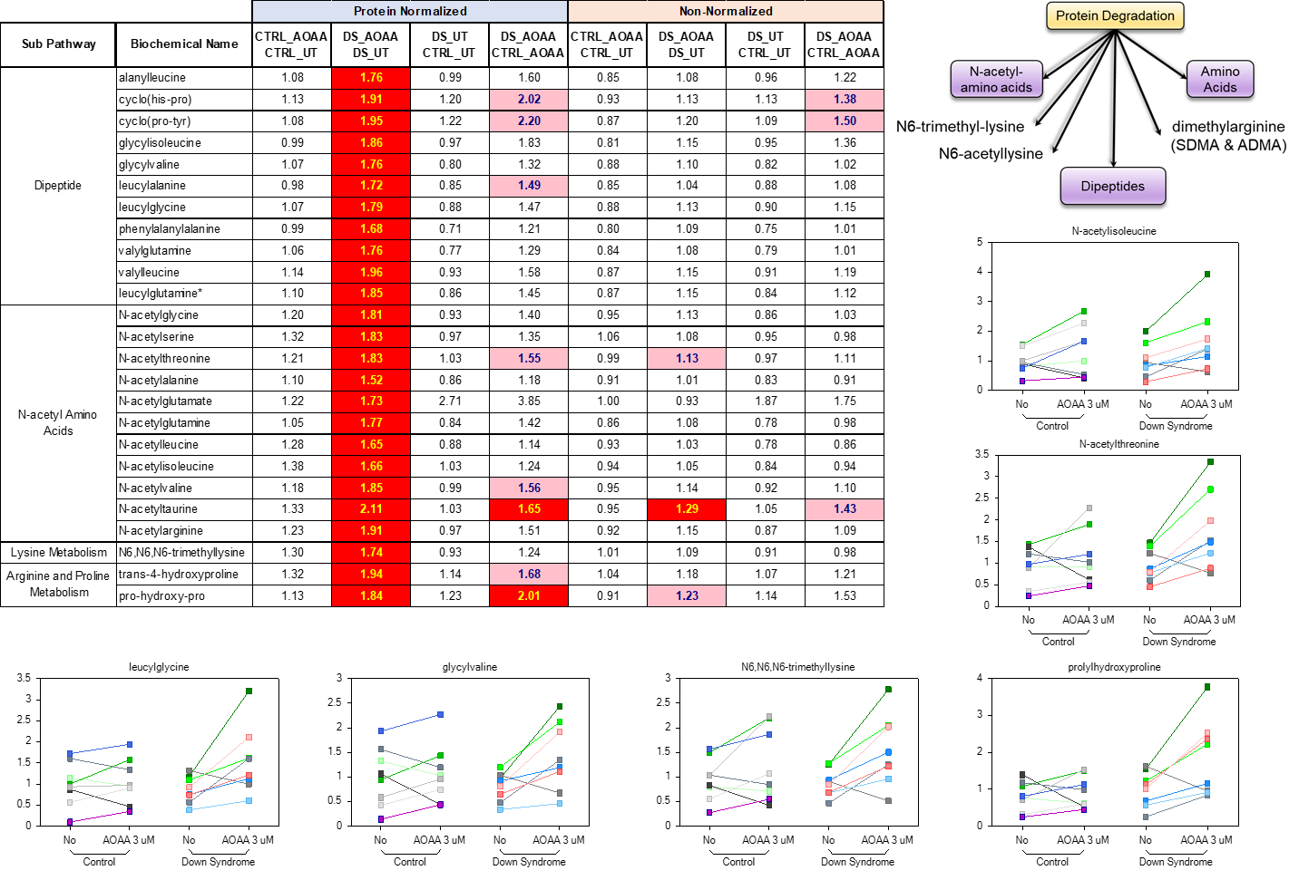
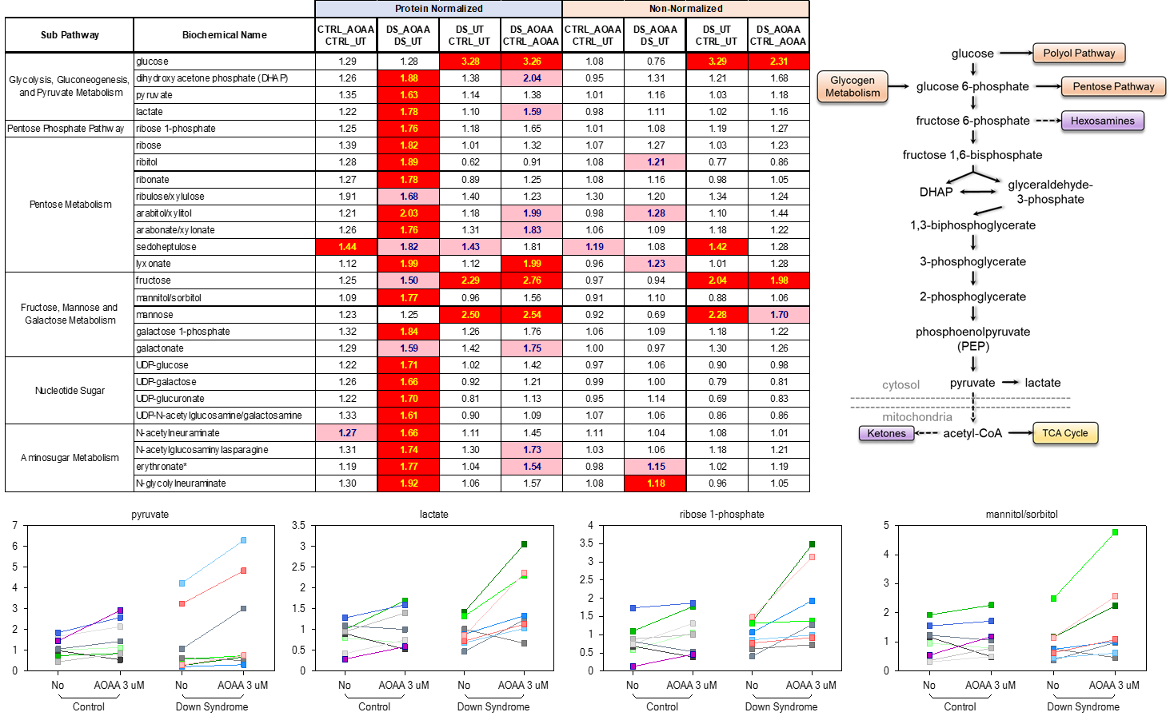
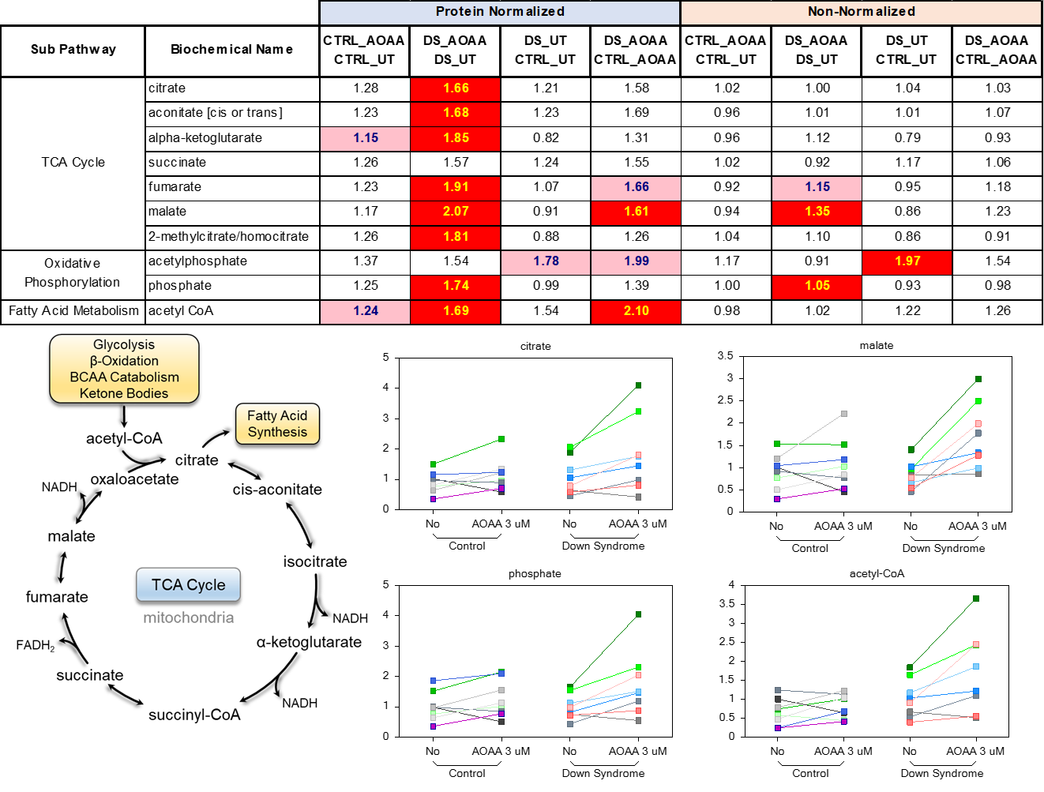
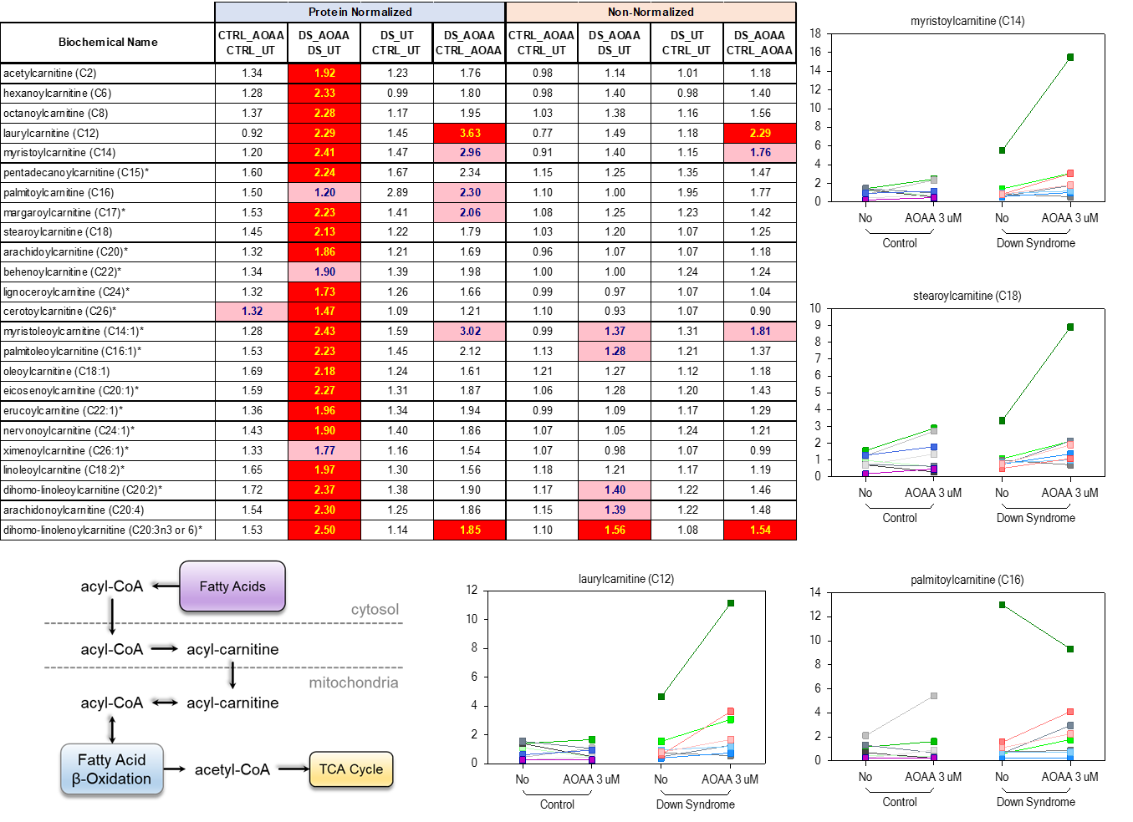
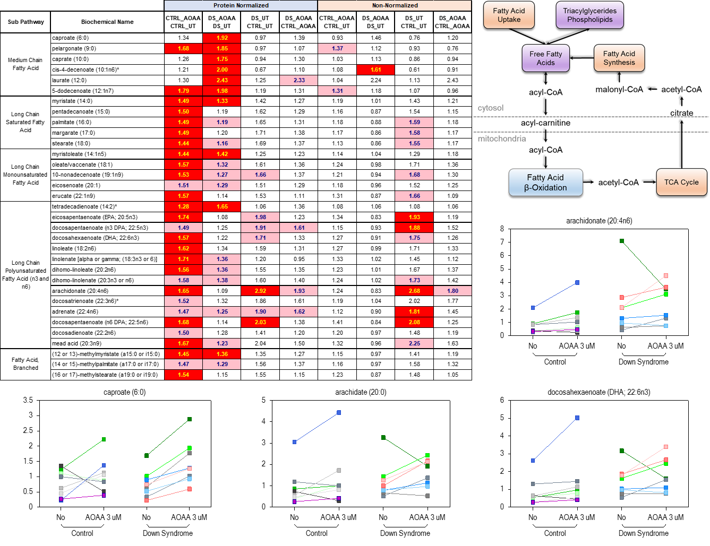
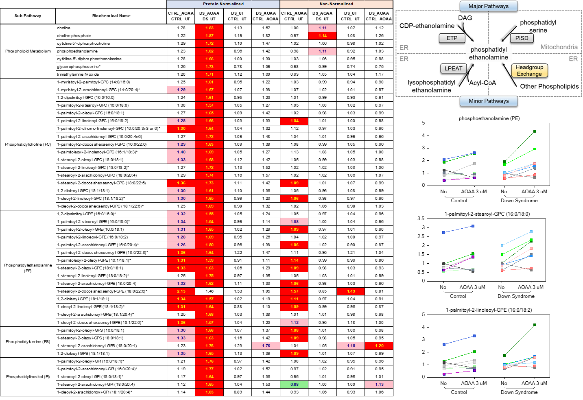
mView™ REPORT
Metabolomic Profiling of Down Syndrome Fibroblasts and Matched Control Fibroblasts

UFRI-01-19VW CO
CLIENT: University of Fribourg
Csaba Szabo, PhD

AUTHOR: Andrew Schwab, PhD
APPROVAL: Brian Ingram, PhD
DATE: November 30, 2020

Metabolon, Inc. • 617 Davis Drive, Suite 100, Morrisville, NC 27560 • (919) 572-1711 www.metabolon.com • Contact: info@metabolon.com

Table of Contents
Objective 5
Experimental Procedures 5
Results and Biological Interpretation 5
Metabolite Summary and Significantly Altered Biochemicals 5
Biological Interpretation 7
Considerations for Data Interpretation. 7
Principle Component Analysis 8
Random Forest 10
Hierarchical Clustering Analysis 11
Transsulfuration Pathway 12
Glutathione Metabolism 14
Vitamin B6 Metabolism 14
Markers of Protein Breakdown 15
Carbohydrate Metabolism 16
Energetic Shifts 17
Phospholipid and Sphingolipid Metabolism 19
Conclusion and Path Forward 20
Study Parameters 22
Data Quality: Instrument and Process Variability 22
Appendix 23
Metabolon Platform 23
Statistical Methods and Terminology 27

Objective

Purpose of Experiment
The goal of this study was to determine if metabolomic changes in fibroblasts derived from Down-syndrome patients can be restored by pharmacological inhibition of cystathionine beta synthase.

Experimental Procedures

Experimental design
Metabolon received 32 samples on September 10th, 2020 and the global metabolomic profiles were determined from the experimental groups outlined in the table below (Figure 1). This study was conducted using human fibroblasts derived from either healthy controls or Down-syndrome (DS) subjects that were either untreated (UT) or treated with AOAA.

Group |  | Description | N
CTRL_UT | Non-treated fibroblasts from matched controls |  | 8
CTRL_AOAA | Human fibroblasts from matched controls treated with CBS inhibitor |  | 8
DS_UT | Non-treated human fibroblasts from Down syndrome patients |  | 8
DS_AOAA | Human fibroblasts from Down syndrome patients treated with CBS inhibitor |  | 8
Figure 1. The experimental design of the study.

Results and Biological Interpretation

Metabolite Summary and Significantly Altered Biochemicals
The present data set is comprised of 678 compounds of known identity (named biochemicals). Following normalization to client provided Bradford protein concentrations, log transformation and imputation of missing values, if any, with the minimum observed value for each compound, ANOVA contrasts were used to identify biochemicals that differed significantly between experimental groups. Analysis by two-way ANOVA with repeated measures identified biochemicals exhibiting significant interaction and main effects for experimental parameters of Cell Line Type (Control vs. DS) and Treatment. A summary of the numbers of biochemicals that achieved statistical significance (p≤0.05), as well as those approaching significance (0.05<p<0.10), is shown below (Figure 2).
An estimate of the false discovery rate (q-value) is calculated to take into account the multiple comparisons that normally occur in metabolomic-based studies. For example, when analyzing 200 compounds, we would expect to see about 10 compounds meeting the p≤0.05 cut-off by random chance. The q-value describes the false discovery rate; a low q-value (q<0.10) is an indication of high confidence in a result. While a higher q-value indicates diminished confidence, it does not necessarily rule out the significance of a result. Other lines of evidence may be taken into consideration when determining whether a result merits further scrutiny. Such evidence may include a) significance in another dimension of the study, b) inclusion in a common pathway with a highly significant compound, or c) residing in a similar functional biochemical family with other significant compounds. Refer to the Appendix for general definitions and further descriptions of false discovery rate and other statistical tests used at Metabolon.

Figure 2. Statistical summary count tables

We have also included in the electronic deliverables, a file with data for each biochemical displayed as box plots like that shown in the example figure below (Figure 3).

Figure 3. Visualization of the study data in box and line plot format.

Biological Interpretation
Cystathionine beta synthase (CBS) is an enzyme involved in the metabolism of sulfur containing amino acids such as methionine. CBS converts homocysteine to cystathionine and occupies a pivotal position at the homocysteine junction where the decision to conserve methionine or to convert it to cysteine via the transsulfuration pathway is made. Importantly, CBS is commonly overexpressed in children with Down Syndrome (DS) and has been associated with reduced levels of homocysteine and methionine in the blood of these subjects (PMID: 11391481). Inhibitors of CBS have been developed including aminooxyacetic acid (AOAA), a non-selective and low-affinity inhibitor for CBS, since it also inhibits other vitamin B6-dependent enzymes. This metabolomic study was undertaken to determine if metabolomic changes in fibroblasts derived from DS patients can be restored by pharmacological inhibition of the CBS with AOAA.

Datasets provided in the mView product can be quite large and contain a great deal of information. To provide an initial focus for further consideration, a few observations are offered below from a cursory view of the data. These are not presented as a comprehensive analysis; the principal investigator, with a much greater knowledge of the experimental system, is encouraged to make a detailed study of the data for additional or alternative interpretations. For convenience, biochemicals are highlighted in bold text in the report when they correspond to data plots and tables shown in figures. Comparison of global biochemical profiles revealed several key metabolic differences as highlighted below.

Considerations for Data Interpretation.
In this study, individual cell samples from these groups were loaded in an equivalent manner across the analytical platforms and the results were normalized to protein levels (provided by the client) prior to statistical analysis. However, protein normalization appeared to overcorrect the data as it resulted in a unidirectional increase in most metabolites when comparing DS AOAA to DS UT (Figure 2, 4). For example, it is quite striking how every statistical comparison in the protein-normalized data set resulted in a unidirectional increase in significantly changed metabolites (Figure 2). This may be because all but one DS cell line had higher protein levels in the untreated conditions relative to treated conditions. Importantly, this result was more varied in the control cells. Specifically, five out of the eight control cell lines had higher protein values in the untreated conditions as compared to their paired treated counterparts. For this reason, we decided to provide and analyze the non-normalized data in addition to the protein-normalized data. While the majority of the focus was put on the protein-normalized data, an effort was made to see if similar trends were apparent in the non-normalized data. In the figure below, a high-level heat map illustrates the unidirectional increase of metabolites in the DS cells treated with AOAA relative to untreated DS cells (Figure 4).

Figure 4. High-level heat map and DS cell protein level comparison.

Metabolon recommends a minimum group size of 30 samples/group for human studies, depending on study design and magnitude of expected phenotype, to balance biological variability within datasets (such as different gender and age included in this dataset). In this study, fewer than the recommended number of samples were submitted for all the groups (n=8).

Principle Component Analysis
PCA is a mathematical procedure that reduces the dimensionality of the data (while retaining most of the variation in a dataset) to allow visual assessment of how similar samples are relative to one another (additional information is provided in the “Statistical Methods and Terminology” section of the Appendix). Populations that have widespread differences are expected to group separately and those with few differences group together. It is important to remember that no discernable separation between the groups does not mean that group dependent changes in metabolite levels cannot be observed, but it does indicate that such changes may be subtle, at least in comparison to the differences arising from natural biological variation. In this study, PCA (using both normalized and non-normalized data) resulted in no clear separation of control and DS groups suggesting that these groups are not overtly metabolically distinct (Figures 5, 6). Of note, samples derived from the same cell lines do appear to cluster together.

Figure 5. Principal component analysis for protein-normalized samples.

Figure 6. Principal component analysis for non-normalized samples.

Random Forest
Next, a machine learning method was used to determine if certain metabolites can distinguish the groups. Random forest is an unbiased and supervised classification technique based on an ensemble of a large number of decision trees. When the full forest is grown, the class predictions are compared to the true classes, generating the “OOB error rate” as a measure of prediction accuracy. Here, a list of the top 30 biochemicals that contributed to the separation of metabolomic profiles was generated and colored by super-pathway classification (Figures 7, 8). Random forest analysis of the treated and untreated control samples resulted in an overall predictive accuracy of 50%, as compared to 50% by random chance alone. This result suggests that random forest is not capable of reliably distinguishing the control groups. On the other hand, random forest analysis of the treated and untreated DS samples resulted in an overall predictive accuracy of 69%, suggesting that random forest is more reliable for distinguishing the DS groups. Notably, random forest analysis of control samples identified numerous lipids in the top 30 while random forest analysis of DS samples resulted in numerous amino acids in the top 30. Together, this result suggests that aspects of lipid and amino acid metabolism may be particularly important in driving group dependent changes. The details and implications for many of the metabolites identified with random forest will be discussed in the following sections.

Figure 7. Random forest analysis of control samples.

Figure 8. Random forest analysis of DS samples.

Hierarchical Clustering Analysis
Hierarchical clustering analysis (HCA) is an unsupervised method for clustering the data and can show large-scale differences based on multiple parameters. Similar to the PCA, HCA showed that control and DS groups largely overlapped (Figure 9). Importantly, the samples clustered together by individual donor, as may be expected from human subjects with disparate ages, ethnicities, and gender. Together with the PCA, this result points to no clear differences in the metabolomic profiles, at least at the group level. However, by analyzing heat map changes for each individual, it does appear that treatment is driving notable biochemical shifts.

Figure 9. Hierarchical clustering analysis.

Transsulfuration Pathway
CBS is a key enzyme in the transsulfuration pathway, where it catalyzes the conversion of homocysteine to cystathionine, which in turn is utilized by cystathionine gamma-lyase (CSE) to produce cysteine. Cysteine can then serve as substrate for another CBS-mediated reaction that generates hydrogen sulfide. Here, treatment with AOAA would be expected to increase levels of homocysteine and possibly cysteine, but statistically significant increases in these metabolites were not observed in response to treatment (Figure 10). However, homocysteine and cysteine levels did display an increased trajectory (higher fold-change value) when comparing AOAA treated control and DS cell lines to untreated conditions. It is worth mentioning that AOAA inhibits both CBS and CSE, and according to one report preferentially inhibits CSE over CBS (PMID: 23488457).

Notably, other metabolites in the transsulfuration pathway were significantly increased in DS cells treated with AOAA including methionine, SAM, and SAH. Important to consider, CBS metabolic pathways are dependent on SAM. More specifically, SAM functions as an allosteric activator of CBS and exerts control on its biosynthesis. For example, low concentrations of SAM result in low CBS activity, thereby funneling homocysteine into the transmethylation cycle toward SAM formation. In contrast, high SAM concentrations funnel homocysteine into the transsulfuration pathway toward cysteine biosynthesis. Here, high levels of SAM may be driving the transsulfuration pathway toward cysteine biosynthesis even in the presence of AOAA. This notion is also supported by increased levels of methionine, which upregulates CBS at the post-transcriptional level.

Figure 10. Biochemical heat and pathway map for transsulfuration and one-carbon metabolism. In the heat map, red (p≤0.05) boxes represent significantly increased biochemicals. Green (p≤0.05) boxes in the heat map represent significantly decreased biochemicals. Light pink boxes represent biochemicals which are trending (0.05<p<0.10) up.

Thus, it is plausible that no major accumulation of homocysteine occurred in these cells because the concentration of AOAA used in the study may not have been sufficient enough to overcome other metabolomic driving forces like high levels of SAM and methionine. Other factors that may be contributing to differences in the transsulfuration pathway activity include elevated levels of betaine, dimethylglycine, and 5-methyltetrahydrofolate as these metabolites link methylation reactions to transsulfuration pathway activity. Lastly, since the transsulfuration pathway is the only pathway capable of removing sulfur-containing amino acids under conditions of excess, transsulfuration pathway activity could be elevated in DS conditions due to increased levels of sulfated metabolites (see Figure 11). Of note, the biochemical changes described above are largely similar in terms of directionality for both protein- and non-normalized data, apart from homocysteine. It is interesting that few significant differences exist between the untreated control and untreated DS cells. This could suggest that CBS activity may not necessarily upregulated in the DS derived cell lines. However, it is possible though that this finding may be influenced by the relatively small population size.

Glutathione Metabolism
Oxidative stress is an imbalance between the production of free radicals and the ability of a biological system to detoxify the reactive intermediates or repair the resulting damage. One of the main antioxidants used to maintain and repair oxidative imbalance is glutathione. Importantly, impairment of the transsulfuration pathway via CBS inhibition may lead to a reduction in cellular glutathione. In this study, levels of reduced glutathione (GSH) and oxidized glutathione (GSSG) were significantly elevated in DS cells treated with AOAA (Figure 11). Combined with additional markers of elevated glutathione recycling and/or demand such as ophthalmate and gamma-glutamyl amino acids, these metabolomic shifts could point to increased oxidative stress in DS cells treated with AOAA. This notion is supported by significantly increased levels of sulfated amino acids such as methionine sulfone and methionine sulfoxide (products of methionine reacting with reactive oxygen species). Notably, this overall biochemical signature is weaker in the non-normalized data set, but the trends were moving in the same general direction.

Figure 11. Biochemical heat and pathway map for glutathione metabolism. In the heat map, red (p≤0.05) boxes represent significantly increased biochemicals. Green (p≤0.05) boxes in the heat map represent significantly decreased biochemicals. Pink and light green boxes represent biochemicals which are trending (0.05<p<0.10) up or down, respectively.

Vitamin B6 Metabolism
Vitamins serve as necessary cofactors for numerous enzymes and their concentrations must be maintained at sufficient levels to ensure biological reactions continue unimpeded. Here, several vitamin-related metabolites were significantly increased in DS cells treated with AOAA (Figure 12 and Client Data Table). Differences in vitamin B6 derivatives (e.g., pyridoxine, pyridoxal, and pyridoxamine) may be particularly important as they are endogenously converted to pyridoxal 5’-phosphate, a coenzyme form of vitamin B6 that is essential for amino acid, serotonin, and sphingolipid synthesis. Importantly, the conversion of homocysteine to cysteine (transsulfuration pathway) requires pyridoxine, and AOAA is a general inhibitor of pyridoxal phosphate-dependent enzymes. Together, these changes could point to additional metabolomic shifts that could be influencing the conversion of homocysteine to cysteine. More broadly, these changes may simply reflect potential bioenergetic differences as well as one-carbon metabolism. This notion is supported by differences in energetic profiles and one-carbon metabolism (see Figures 10, 14, 15). Notably, in the non-normalized data set, the biochemical changes were less prominent.

Figure 12. Biochemical heat map for Vitamin B6 metabolism. In the heat map, red (p≤0.05) boxes represent significantly increased biochemicals. Pink boxes represent biochemicals which are trending (0.05<p<0.10) up.

Markers of Protein Breakdown
Proteins are often post-translationally modified by the addition of acetyl- or methyl-groups to amino acid residues, which is important in maintaining protein stability and function. Thus, altered levels of individual and/or N-acetylated amino acids are often indications of perturbed protein turnover and/or utilization. In this study, markers of elevated protein degradation were observed including significantly increased levels of N-acetyl amino acids and free amino acids (Figure 13 and Client Data Table). In addition to amino acid shifts, differences in dipeptides can reflect altered protein catabolism. Here, several dipeptides were significantly increased in DS cells treated with AOAA. Other markers of protein degradation were also similarly elevated including N6-trimethyllysine, trans-4-hydroxyproline, and pro-hydroxy-pro.

Figure 13. Biochemical heat and pathway map for markers of protein homeostasis. In the heat map, red (p≤0.05) boxes represent significantly increased biochemicals. Pink boxes represent biochemicals which are trending (0.05<p<0.10) up.

Carbohydrate Metabolism
Glucose is a fuel substrate utilized for energy production and storage, NADPH and pentose sugar generation, and glycosylation. Through glycolysis, glucose is oxidized to form pyruvate to fuel energy production in the TCA cycle. Alternatively, glucose can be directed into the pentose phosphate pathway to generate NADPH (for glutathione recycling and fatty acid synthesis) and ribose-5-phosphate (for nucleotide biosynthesis). Here, DS cells treated with AOAA resulted in significantly increased levels of glycolytic intermediates, pentose metabolites, and other sugar-related metabolites (Figure 14). Since pyruvate is the final product of aerobic glycolysis, elevated pyruvate levels with treatments may indicate increased glycolysis or stalled entry into the TCA cycle. A rise in ribose and related metabolites could point to increased nucleotide synthesis. Indeed, several nucleotide metabolites were increased in DS cells (see Client Data Table). Together, these changes in DS cells may reflect important shifts in energetic and biosynthetic demands. Speculatively, these biochemical shifts could point to differences in cellular proliferation or hypoxic growth conditions. It is also worth mentioning that AOAA has been reported to prevent the mitochondria from utilizing pyruvate generated from glycolysis. More specifically, AOAA prevents the re-oxidation of cytosolic NADH by the mitochondria by inhibiting the malate-aspartate shuttle, causing an increase in the lactate/pyruvate ratio and an inhibition of the ability of the mitochondria to utilize glycolytic pyruvate (PMID: 3620514).

Figure 14. Biochemical heat and pathway map for carbohydrate metabolism. In the heat map, red (p≤0.05) boxes represent significantly increased biochemicals. Pink boxes represent biochemicals which are trending (0.05<p<0.10) up.

Energetic Shifts
The tri-carboxylic acid (TCA) cycle is an integral part of mitochondrial metabolism and changes in TCA cycle intermediates with disease or drug are often reflections of mitochondrial function and can further provide evidence of altered fuel substrate metabolism. In this study, increased levels of TCA cycle intermediates following AOAA treatment in DS cells is perhaps indicative of increased TCA cycle activity (Figure 15). Moreover, an increase in phosphate levels, an essential energy metabolite, and acetyl CoA could suggest increased oxidative phosphorylation and overall energetics. Important to consider, AOAA inhibits aspartate aminotransferase, another PLP-dependent enzyme that is an essential part of the malate-aspartate shuttle, which prevents the re-oxidation of cytosolic NADH by the mitochondria (PMID: 3620514). Notably, malate was significantly increased in DS cells with AOAA treatment in both protein- and non-normalized data sets. Of potential interest to the client, a metabolomic study using normal and transformed cells indicated that, in addition to the effect on the TCA cycle, AOAA decreased production of adenosine triphosphate (PMID: 27157912).

Figure 15. Biochemical heat and pathway map for energetic-related metabolites. In the heat map, red (p≤0.05) boxes represent significantly increased biochemicals. Pink boxes represent biochemicals which are trending (0.05<p<0.10) up.

β-oxidation serves as the primary mechanism by which fatty acids are oxidized for energy production. During mitochondrial β-oxidation, acyl-CoAs undergo sequential removal of two carbons to produce acetyl-CoA, which can be further oxidized in the TCA cycle. In many cases, acylcarnitine levels, which are more often detected on Metabolon’s global untargeted platform than acyl-CoA species, reflect their respective CoA counterparts. Notably, the enzyme carnitine palmitoyl transferase, which transfers carnitine to acyl-chains to facilitate transport of fatty acids across the mitochondrial membrane, is the rate-limiting enzyme in fatty acid β-oxidation. Thus, acylcarnitine levels can provide clues regarding the overall activity of the β-oxidation pathway. In this study, AOAA treatment of DS cells resulted in a widespread increase in acylcarnitine levels (Figure 16). Notably, in both protein- and non-normalized data sets, DS cells resulted in the most widespread and significant shifts. Together, these results could suggest that AOAA treatment results in increased β-oxidation activity in DS cells. This notion is supported by the fact that free fatty acid levels were increased by AOAA treatment which could suggest mobilization of fatty acids for β-oxidation (Figure 17).

Figure 16. Biochemical heat and pathway map for acylcarnitine metabolism. In the heat map, red (p≤0.05) boxes represent significantly increased biochemicals. Pink boxes represent biochemicals which are trending (0.05<p<0.10) up.

Figure 17. Biochemical heat and pathway map for free fatty acids. In the heat map, red (p≤0.05) boxes represent significantly increased biochemicals. Pink boxes represent biochemicals which are trending (0.05<p<0.10) up.

Phospholipid and Sphingolipid Metabolism
Phospholipids and sphingolipids are primary components of cell membranes and lipoprotein particles and play key roles in cell survival, membrane dynamics, adaptions to stress, and overall cellular metabolism. Here, DS and control cells treated with AOAA resulted in a widespread elevation of phospholipids and sphingolipids (Figure 18 and Client Data Table). Together, increased levels of phospholipids and sphingolipids could further reflect elevated levels of membrane turnover with treatment, perhaps a sign of altered cellular proliferation. Speculatively, increased levels of phospholipids may suggest increased synthesis for incorporation into cellular membranes, which could reflect elevated levels of membrane synthesis needed for cellular proliferation and/or transformation. Of note, when analyzing the non-normalized data set, an increase in phospholipids was predominantly observed in just control cells treated with AOAA.

Figure 18. Biochemical heat and pathway map for phospholipid metabolism. In the heat map, red (p≤0.05) boxes represent significantly increased biochemicals. Light green boxes represent biochemicals which are trending (0.05<p<0.10) down.

Conclusion and Path Forward
This global metabolomic analysis elucidated biochemical fingerprints of AOAA treatment in DS and control cells. Unfortunately, metabolomic analysis resulted in minimal significant biochemical changes to metabolites that would be expected to change based on AOAA-mediated inhibition of CBS (e.g., homocysteine and cysteine). Nonetheless, AOAA treatment resulted in notable biochemical shifts in transsulfuration-related metabolites, vitamins, biochemicals associated with cellular energetics, and lipid metabolites. Notably, these biochemical changes were primarily manifested in the DS cells. Differences in transsulfuration-related metabolites were notable in DS cells and may point to elevated transsulfuration activities due to increased input of SAM, methionine, and transmethylation reactions. Perhaps, this is indicative of a compensatory response of DS cells to overcome AOAA-mediated inhibition of CBS and CSE. Additionally, increased levels of sulfur-containing compounds after AOAA treatment may point towards increased transsulfuration pathway activity needed to handle altered redox homeostasis. Changes in vitamin B6 metabolites were prominent and could point to additional biochemical shifts that could be influencing CBS conversion of homocysteine to cysteine. Alterations in glycolytic activity, TCA cycle intermediates, free fatty acids, and acylcarnitines suggest that AOAA is affecting fatty acid synthesis/utilization and β-oxidation, perhaps reflective of altered cellular growth. Moreover, differences in the phospholipid and sphingolipid profiles in DS cells, and to some extent control cells, are potentially indicative of membrane associated changes, possibly as a result of altered cellular proliferation. While speculative, widespread changes in DS cells with AOAA treatment could also reflect fibroblast transformation. This notion is supported by a recent report suggesting that hydrogen sulfide facilitates reprogramming and trans-differentiation of fibroblasts (PMID: 33180827).

The notion of altered cellular proliferation as a result of AOAA is important to consider as AOAA is reported to decrease proliferation of malignantly transformed fibroblasts, fibrosarcoma-derived cells, and cancer cells (PMID: 28923859, 24667534, 23836652, 29061341). Other biochemical signatures that could suggest decreased proliferation in DS cells treated with AOAA included a rise in amino acids, polyamines, carbohydrates, creatine, and energetic metabolites. If proliferation is indeed impacted, it is curious as to why these changes were only manifested in DS cells and not control cells. Speculatively, there could be a difference between enzyme potency in DS and control cells and the efficacy of AOAA may be different due to differential cellular uptake. It is plausible that AOAA is being taken up more readily by the DS cells as compared to the controls, especially if the proliferation rates differ. If true, this could potentially explain many of the biochemical signatures identified in this study. Of potential interest to the client, one group developed a methyl ester prodrug of AOAA to increase its ability for cellular uptake (PMID: 27257787).

Importantly, many of the changes in the dataset are likely being biased by overcorrection following protein normalization, though similar trends can be seen in the non-normalized dataset in many cases, albeit with limited statistical significance and smaller fold-change values. The non-normalized data is very similar to what we observed the first time we did the study in that overall statistically significant differences were limited across the group comparisons. Given the potential for biases here, it is recommended to consider other normalization methods, particularly if other parameters are available such as cell counts or DNA levels.

Moving forward, the client is encouraged to correlate the metabolomic changes to cellular performance data such as cell viability, cell size, growth curves, pH, and protein activity assays. Additional analysis of fresh media and supernatant samples could provide insight into process and metabolomic differences that could help to understand substrate utilization. It is also recommended to assess protein readouts of fibroblast transformation. Lastly, analysis of the metabolomic changes at the individual level may be warranted. This is especially important since many of the metabolomic changes identified in this study appear to be largely driven by a handful of individuals. Importantly, this could identify cell lines that are responders and non-responders to AOAA and could point to metabolomic differences contributing to these phenotypes.

Study Parameters

Data Quality: Instrument and Process Variability

QC Sample | Measurement | Median RSD
Internal Standards | Instrument Variability | 5%
Endogenous Biochemicals | Total Process Variability | 18%
Instrument variability was determined by calculating the median relative standard deviation (RSD) for the internal standards that were added to each sample prior to injection into the mass spectrometers. Overall process variability was determined by calculating the median RSD for all endogenous metabolites (i.e., non-instrument standards) present in 100% of the Client Matrix samples, which are technical replicates of pooled client samples. Values for instrument and process variability meet Metabolon’s acceptance criteria as shown in the table above.

Appendix

Metabolon Platform
Sample Accessioning: Following receipt, samples were inventoried and immediately stored at -80ºC. Each sample received was accessioned into the Metabolon LIMS system and was assigned by the LIMS a unique identifier that was associated with the original source identifier only. This identifier was used to track all sample handling, tasks, results, etc. The samples (and all derived aliquots) were tracked by the LIMS system. All portions of any sample were automatically assigned their own unique identifiers by the LIMS when a new task was created; the relationship of these samples was also tracked. All samples were maintained at -80ºC until processed.
Sample Preparation: Samples were prepared using the automated MicroLab STAR® system from Hamilton Company. Several recovery standards were added prior to the first step in the extraction process for QC purposes. To remove protein, dissociate small molecules bound to protein or trapped in the precipitated protein matrix, and to recover chemically diverse metabolites, proteins were precipitated with methanol under vigorous shaking for 2 min (Glen Mills GenoGrinder 2000) followed by centrifugation. The resulting extract was divided into five fractions: two for analysis by two separate reverse phase (RP)/UPLC-MS/MS methods with positive ion mode electrospray ionization (ESI), one for analysis by RP/UPLC-MS/MS with negative ion mode ESI, one for analysis by HILIC/UPLC-MS/MS with negative ion mode ESI, and one sample was reserved for backup. Samples were placed briefly on a TurboVap® (Zymark) to remove the organic solvent. The sample extracts were stored overnight under nitrogen before preparation for analysis.
QA/QC: Several types of controls were analyzed in concert with the experimental samples: a pooled matrix sample generated by taking a small volume of each experimental sample (or alternatively, use of a pool of well-characterized human plasma) served as a technical replicate throughout the data set; extracted water samples served as process blanks; and a cocktail of QC standards that were carefully chosen not to interfere with the measurement of endogenous compounds were spiked into every analyzed sample, allowed instrument performance monitoring and aided chromatographic alignment. Tables 1 and 2 describe these QC samples and standards. Instrument variability was determined by calculating the median relative standard deviation (RSD) for the standards that were added to each sample prior to injection into the mass spectrometers. Overall process variability was determined by calculating the median RSD for all endogenous metabolites (i.e., non-instrument standards) present in 100% of the pooled matrix samples. Experimental samples were randomized across the platform run with QC samples spaced evenly among the injections, as outlined in Figure 1.
Table 1: Description of Metabolon QC Samples
Type | Description | Purpose
MTRX | Large pool of human plasma maintained by Metabolon that has been characterized extensively. | Assure that all aspects of the Metabolon process are operating within specifications.
CMTRX | Pool created by taking a small aliquot from every customer sample. | Assess the effect of a non-plasma matrix on the Metabolon process and distinguish biological variability from process variability.
PRCS | Aliquot of ultra-pure water | Process Blank used to assess the contribution to compound signals from the process.
SOLV | Aliquot of solvents used in extraction. | Solvent Blank used to segregate contamination sources in the extraction.
Table 2: Metabolon QC Standards
Type | Description | Purpose
RS | Recovery Standard | Assess variability and verify performance of extraction and instrumentation.
IS | Internal Standard | Assess variability and performance of instrument.

Figure 1. Preparation of client-specific technical replicates. A small aliquot of each client sample (colored cylinders) is pooled to create a CMTRX technical replicate sample (multi-colored cylinder), which is then injected periodically throughout the platform run. Variability among consistently detected biochemicals can be used to calculate an estimate of overall process and platform variability.
Ultrahigh Performance Liquid Chromatography-Tandem Mass Spectroscopy (UPLC-MS/MS): All methods utilized a Waters ACQUITY ultra-performance liquid chromatography (UPLC) and a Thermo Scientific Q-Exactive high resolution/accurate mass spectrometer interfaced with a heated electrospray ionization (HESI-II) source and Orbitrap mass analyzer operated at 35,000 mass resolution. The sample extract was dried then reconstituted in solvents compatible to each of the four methods. Each reconstitution solvent contained a series of standards at fixed concentrations to ensure injection and chromatographic consistency. One aliquot was analyzed using acidic positive ion conditions, chromatographically optimized for more hydrophilic compounds. In this method, the extract was gradient eluted from a C18 column (Waters UPLC BEH C18-2.1x100 mm, 1.7 µm) using water and methanol, containing 0.05% perfluoropentanoic acid (PFPA) and 0.1% formic acid (FA). Another aliquot was also analyzed using acidic positive ion conditions, however it was chromatographically optimized for more hydrophobic compounds. In this method, the extract was gradient eluted from the same afore mentioned C18 column using methanol, acetonitrile, water, 0.05% PFPA and 0.01% FA and was operated at an overall higher organic content. Another aliquot was analyzed using basic negative ion optimized conditions using a separate dedicated C18 column. The basic extracts were gradient eluted from the column using methanol and water, however with 6.5mM Ammonium Bicarbonate at pH 8. The fourth aliquot was analyzed via negative ionization following elution from a HILIC column (Waters UPLC BEH Amide 2.1x150 mm, 1.7 µm) using a gradient consisting of water and acetonitrile with 10mM Ammonium Formate, pH 10.8. The MS analysis alternated between MS and data-dependent MS^{n} scans using dynamic exclusion. The scan range varied slighted between methods but covered 70-1000 m/z. Raw data files are archived and extracted as described below.
Bioinformatics: The informatics system consisted of four major components, the Laboratory Information Management System (LIMS), the data extraction and peak-identification software, data processing tools for QC and compound identification, and a collection of information interpretation and visualization tools for use by data analysts. The hardware and software foundations for these informatics components were the LAN backbone, and a database server running Oracle 10.2.0.1 Enterprise Edition.
LIMS: The purpose of the Metabolon LIMS system was to enable fully auditable laboratory automation through a secure, easy to use, and highly specialized system. The scope of the Metabolon LIMS system encompasses sample accessioning, sample preparation and instrumental analysis and reporting and advanced data analysis. All of the subsequent software systems are grounded in the LIMS data structures. It has been modified to leverage and interface with the in-house information extraction and data visualization systems, as well as third party instrumentation and data analysis software.
Data Extraction and Compound Identification: Raw data was extracted, peak-identified and QC processed using Metabolon’s hardware and software. These systems are built on a web-service platform utilizing Microsoft’s .NET technologies, which run on high-performance application servers and fiber-channel storage arrays in clusters to provide active failover and load-balancing. Compounds were identified by comparison to library entries of purified standards or recurrent unknown entities. Metabolon maintains a library based on authenticated standards that contains the retention time/index (RI), mass to charge ratio (m/z), and chromatographic data (including MS/MS spectral data) on all molecules present in the library. Furthermore, biochemical identifications are based on three criteria: retention index within a narrow RI window of the proposed identification, accurate mass match to the library +/- 10 ppm, and the MS/MS forward and reverse scores between the experimental data and authentic standards. The MS/MS scores are based on a comparison of the ions present in the experimental spectrum to the ions present in the library spectrum. While there may be similarities between these molecules based on one of these factors, the use of all three data points can be utilized to distinguish and differentiate biochemicals. More than 3300 commercially available purified standard compounds have been acquired and registered into LIMS for analysis on all platforms for determination of their analytical characteristics. Additional mass spectral entries have been created for structurally unnamed biochemicals, which have been identified by virtue of their recurrent nature (both chromatographic and mass spectral). These compounds have the potential to be identified by future acquisition of a matching purified standard or by classical structural analysis.
Curation: A variety of curation procedures were carried out to ensure that a high quality data set was made available for statistical analysis and data interpretation. The QC and curation processes were designed to ensure accurate and consistent identification of true chemical entities, and to remove those representing system artifacts, mis-assignments, and background noise. Metabolon data analysts use proprietary visualization and interpretation software to confirm the consistency of peak identification among the various samples. Library matches for each compound were checked for each sample and corrected if necessary.

Metabolite Quantification and Data Normalization: Peaks were quantified using area-under-the-curve. For studies spanning multiple days, a data normalization step was performed to correct variation resulting from instrument inter-day tuning differences. Essentially, each compound was corrected in run-day blocks by registering the medians to equal one (1.00) and normalizing each data point proportionately (termed the “block correction”; Figure 2). For studies that did not require more than one day of analysis, no normalization is necessary, other than for purposes of data visualization. In certain instances, biochemical data may have been normalized to an additional factor (e.g., cell counts, total protein as determined by Bradford assay, osmolality, etc.) to account for differences in metabolite levels due to differences in the amount of material present in each sample.
Figure 2: Visualization of data normalization steps for a multiday platform run.

Statistical Methods and Terminology
Statistical Calculations: For many studies, two types of statistical analysis are usually performed: (1) significance tests and (2) classification analysis. Standard statistical analyses are performed in ArrayStudio on log transformed data. For those analyses not standard in ArrayStudio, the programs R (http://cran.r-project.org/) or JMP are used. Below are examples of frequently employed significance tests and classification methods followed by a discussion of p- and q-value significance thresholds.

- One-way ANOVA
ANOVA stands for analysis of variance. For ANOVA, it is assumed that all populations have the same variances. One-way ANOVA is used to test whether at least two unknown means are all equal or whether at least one pair of means is different. For the case of two means, ANOVA gives the same result as a two-sided t-test with a pooled estimate of the variance.

An ANOVA uses an F-test which has two parameters – the numerator degrees of freedom and the denominator degrees of freedom. The degrees of freedom in the numerator are equal to g – 1, where g is the number of groups. If n is the total number of observations (n₁ + n₂), then, the denominator degrees of freedom is equal to n – g. The F-statistic is the ratio of the between-groups variance to the within-groups variance, hence the higher the F-statistic the more evidence we have that the means are different.

Often within ANOVA, one performs linear contrasts for specific comparisons of interest. For example, suppose we have three groups A, B, C, then examples of some contrasts are A vs. B, the average of A and B vs. C, etc. For single-degree of freedom contrasts, these give the same result as a two-sided t-test with the pooled estimate of the variance from the ANOVA and degrees of freedom n – g. Below, we show the three formulas for A vs. B from a three group design as shown above. The numerator is same in each case, but the denominator differs by the estimates of the variances, and the degrees of freedom are different for each (if the theoretical assumptions hold, then the contrast has the most power, as it has the largest degrees of freedom).

Welch’s two-sample t-test
By t , and the degrees of freedom is given by

Two-sample t-test with pooled estimate of variance from A and B

where , where the degrees of freedom is n_{A} + n_{B} – 2.
The contrast from the ANOVA,

where , where the degrees of freedom is given by where the degrees of freedom is n_{A} + n_{B} + n_{C} – 3.

- Two-way ANOVA
ANOVA stands for analysis of variance. For ANOVA, it is assumed that all populations have the same variances. For a two-way ANOVA, three statistical tests are typically performed: the main effect of each factor and the interaction. Suppose we have two factors A and B, where A represent the genotype and B represent the diet in a mouse study. Suppose each of these factors has two levels (A: wild type, knock out; B: standard diet, high fat diet). For this example, there are 4 combinations (“treatments”): A1B1, A1B2, A2B1, A2B2. The overall ANOVA F-test gives the p-value for testing whether all four of these means are equal or whether at least one pair is different. However, we are also interested in the effect of the genotype and diet. A main effect is a contrast that tests one factor across the levels of the other factor. Hence the A main effect compares (A1B1 + A1B2)/2 vs. (A2B1 + A2B2)/2, and the B-main effect compares (A1B1 + A2B1)/2 vs. (A1B2 + A2B2)/2. The interaction is a contrast that tests whether the mean difference for one factor depends on the level of the other factor, which is (A1B2 + A2B1)/2 vs. (A1B1 + A2B2)/2.

Some sample plots follow. For the first plot, there is a B main effect, but no A main effect and no interaction, as the effect of B does not depend on the level of A. For the second plot, notice how the mean difference for B is the same at each level of A and the difference in A is the same for each level of B, hence there is no statistical interaction. The final plot also has main effects for A and B, but here also has an interaction: we see the effect of B depends on the level of A (0 for A1 but 2 for A2), i.e., the effect of the diet depends on the genotype. We also see here the interpretation of the main effects depends on whether there is an interaction or not.

- Two-way Repeated Measures ANOVA
This is typically an ANOVA where one factor is applied to each subject and the second factor is a time point. See two-way ANOVA as many of the details are similar except that the model takes into account the repeated measures, i.e., the treatments are given to the same subject over time. The two main effects and the interaction are assessed, with particular interest to the interaction, as this shows where the time profiles are parallel or not for the treatments (parallel mean no interaction).

One additional note, the standard analysis assumes a condition referred to as compound symmetry, which assumes the correlation between each pair of levels of the repeated-measures factor is the same. Thus, for the case of time, it assumes the correlation is the same between time points 1 and 2, 1 and 3, and 2 and 3.

- p- values
For statistical significance testing, p-values are given. The lower the p-value, the more evidence we have that the null hypothesis (typically that two population means are equal) is not true. If “statistical significance” is declared for p-values less than 0.05, then 5% of the time we incorrectly conclude the means are different, when actually they are the same.

The p-value is the probability that the test statistic is at least as extreme as observed in this experiment given that the null hypothesis is true. Hence, the more extreme the statistic, the lower the p-value and the more evidence the data gives against the null hypothesis.

- q-values
The level of 0.05 is the false positive rate when there is one test. However, for a large number of tests we need to account for false positives. There are different methods to correct for multiple testing. The oldest methods are family-wise error rate adjustments (Bonferroni, Tukey, etc.), but these tend to be extremely conservative for a very large number of tests. With gene arrays, using the False Discovery Rate (FDR) is more common. The family-wise error rate adjustments give one a high degree of confidence that there are zero false discoveries. However, with FDR methods, one can allow for a small number of false discoveries. The FDR for a given set of compounds can be estimated using the q-value (see Storey J and Tibshirani R. (2003) Statistical significance for genomewide studies. Proc. Natl. Acad. Sci. USA 100: 9440-9445; PMID: 12883005).

In order to interpret the q-value, the data must first be sorted by the p-value then choose the cutoff for significance (typically p<0.05). The q-value gives the false discovery rate for the selected list (i.e., an estimate of the proportion of false discoveries for the list of compounds whose p-value is below the cutoff for significance). For Table 1 below, if the whole list is declared significant, then the false discovery rate is approximately 10%. If everything from Compound 079 and above is declared significant, then the false discovery rate is approximately 2.5%.
Table 1: Example of q-value interpretation

- Random Forest

Random forest is a supervised classification technique based on an ensemble of decision trees (see Breiman L. (2001) Random Forests. Machine Learning. 45: 5-32; http://link.springer.com/article/10.1023%2FA%3A1010933404324). For a given decision tree, a random subset of the data with identifying true class information is selected to build the tree (“bootstrap sample” or “training set”), and then the remaining data, the “out-of-bag” (OOB) variables, are passed down the tree to obtain a class prediction for each sample. This process is repeated thousands of times to produce the forest. The final classification of each sample is determined by computing the class prediction frequency (“votes”) for the OOB variables over the whole forest. For example, suppose the random forest consists of 50,000 trees and that 25,000 trees had a prediction for sample 1. Of these 25,000, suppose 15,000 trees classified the sample as belonging to Group A and the remaining 10,000 classified it as belonging to Group B. Then the votes are 0.6 for Group A and 0.4 for Group B, and hence the final classification is Group A. This method is unbiased since the prediction for each sample is based on trees built from a subset of samples that do not include that sample. When the full forest is grown, the class predictions are compared to the true classes, generating the “OOB error rate” as a measure of prediction accuracy. Thus, the prediction accuracy is an unbiased estimate of how well one can predict sample class in a new data set. Random forest has several advantages – it makes no parametric assumptions, variable selection is not needed, it does not overfit, it is invariant to transformation, and it is fairly easy to implement with R.

To determine which variables (biochemicals) make the largest contribution to the classification, a “variable importance” measure is computed. We use the “Mean Decrease Accuracy” (MDA) as this metric. The MDA is determined by randomly permuting a variable, running the observed values through the trees, and then reassessing the prediction accuracy. If a variable is not important, then this procedure will have little change in the accuracy of the class prediction (permuting random noise will give random noise). By contrast, if a variable is important to the classification, the prediction accuracy will drop after such a permutation, which we record as the MDA. Thus, the random forest analysis provides an “importance” rank ordering of biochemicals; we typically output the top 30 biochemicals in the list as potentially worthy of further investigation.

- Hierarchical Clustering
Hierarchical clustering is an unsupervised method for clustering the data, and can show large-scale differences. There are several types of hierarchical clustering and many distance metrics that can be used. A common method is complete clustering using the Euclidean distance, where each sample is a vector with all of the metabolite values. The differences seen in the cluster may be unrelated to the treatment groups or study design.

- Principal Components Analysis (PCA)
Principal components analysis is an unsupervised analysis that reduces the dimension of the data. Each principal component is a linear combination of every metabolite and the principal components are uncorrelated. The number of principal components is equal to the number of observations.

The first principal component is computed by determining the coefficients of the metabolites that maximizes the variance of the linear combination. The second component finds the coefficients that maximize the variance with the condition that the second component is orthogonal to the first. The third component is orthogonal to the first two components and so on. The total variance is defined as the sum of the variances of the predicted values of each component (the variance is the square of the standard deviation), and for each component, the proportion of the total variance is computed. For example, if the standard deviation of the predicted values of the first principal component is 0.4 and the total variance = 1, then 100*0.4*0.4/1 = 16% of the total variance is explained by the first component. Since this is an unsupervised method, the main components may be unrelated to the treatment groups, and the “separation” does not give an estimate of the true predictive ability.

